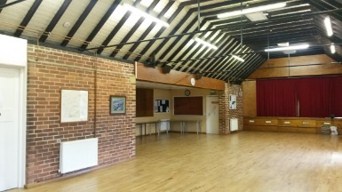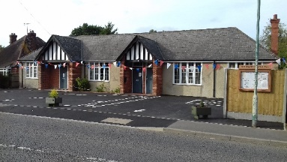

High Halden War Memorial Hall Privacy Notice
‘High Halden War Memorial Hall Management Committee uses personal data for the purposes of managing the hall, its bookings and finances, running and marketing events at the hall, staff employment and its fundraising activities. Data may be retained for up to 7 years for accounts purposes and for longer where required by the hall’s insurers. If you would like to find out more about how we use your personal data or want to see a copy of information about you that we hold, please contact the hall Secretary’.
Consent Forms will be obtained where personal data will be displayed on notice boards or the hall website or where it is needed for registration with the Charity Commission.
Consent forms will be stored by the Secretary in a securely held electronic or paper file.

Privacy notice reviewed Nov 22
This privacy notice is in line with guidance issued by ACRE in information sheet Data Protection for Village Halls and Community Buildings - A Preliminary Guide reviewed April 2021
See Full Data Protection Policy – Reviewed Nov 22

